# CYK Parsing

## Description

CYK (Cocke-Younger-Kasami) is a parsing algorithm used to determine if a string can be generated by a given context-free grammar. The algorithm works by filling up a table with partial derivations and recursively combining them until the final string is found or determined to not be in the language. It has a time complexity of O(n^3) where n is the length of the input string.

### The following are a few sentences that will be parsed using CKY in this project :

I want to book a hotel in Tokyo

we're flying to NewYork

renting a car is expensive in Califonia

can you recommend a good restaurant in Miami

the beach in Tokyo is beautiful

we booked a flight to NewYork and a hotel in Manhattan

an Airbnb is cheaper than a hotel in Miami

I want to visit the Empire State Building in NewYork

the food in Miami is delicious

we're flying to Califonia and renting a car to drive to NewYork

the flight from NewYork to Miami is long

I need to book a table at a fancy restaurant in Miami

we're going to the beach in Miami and the Golden Gate Park in San Francisco

renting a car in Miami and driving to Key West is a popular option

the hotel in Califonia has a great view of the Cambridge

### CFG :

S -> NP VP

NP -> Pronoun | ProperNoun | Determiner Nominal

Nominal -> Noun | Adjective Nominal

VP -> Verb | Verb NP | Verb NP PP | Verb PP | VP Conjunction VP

PP -> Preposition NP

ProperNoun -> 'Califonia' | 'NewYork' | 'Tokyo' | 'Miami' | 'Manhattan'

Determiner -> 'a' | 'an' | 'the'

Noun -> 'hotel' | 'flight' | 'car' | 'restaurant' | 'beach'

Adjective -> 'beautiful' | 'delicious' | 'expensive' | 'cheap' | 'long'

Verb -> 'book' | 'fly' | 'rent' | 'visit' | 'eat'

Preposition -> 'to' | 'in' | 'at'

Pronoun -> 'I' | 'we' | 'you' | 'it'

Conjunction -> 'and' | 'or'

### CYK Tables for Valid Sentences:

1. I book a hotel in Tokyo

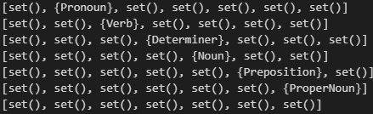

1. we fly to NewYork

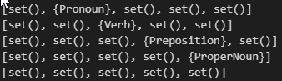

1. a car is expensive in Califonia

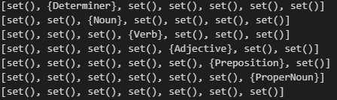

1. you recommend a good restaurant in Miami

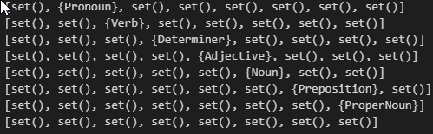

1. the beach in Tokyo is beautiful

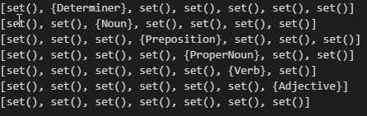

1. we book a flight to NewYork and a hotel in Manhattan

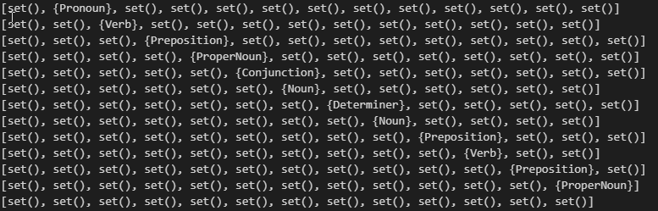

1. an Airbnb is cheap in Miami

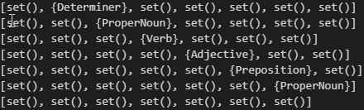

1. I visit the K in NewYork

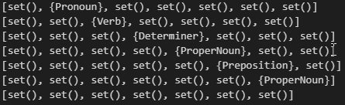

1. the food in Miami is delicious



1. we fly to Califonia and renting a car to drive to NewYork



1. the flight from NewYork to Miami is long

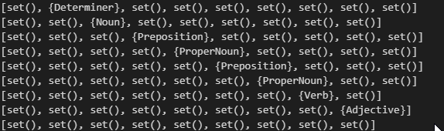

1. I need to book a table at a fancy restaurant in Miami

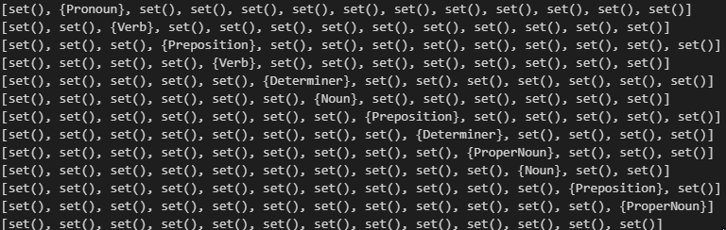

### CYK Tables for Invalid Sentences:

1. we're going to the beach in Miami and the Golden Gate Park in San Francisco

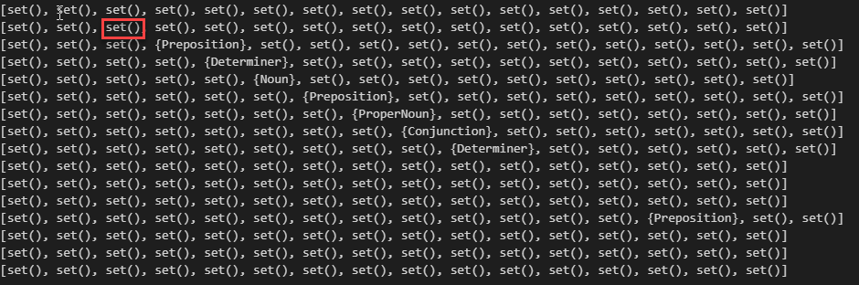

1. renting a car in Miami and driving to Key West is a popular option

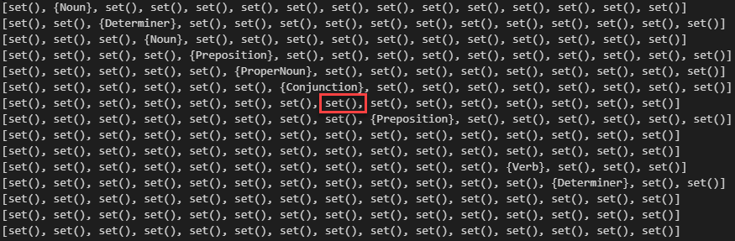

1. the hotel in Califonia has a great view of the Cambridge

